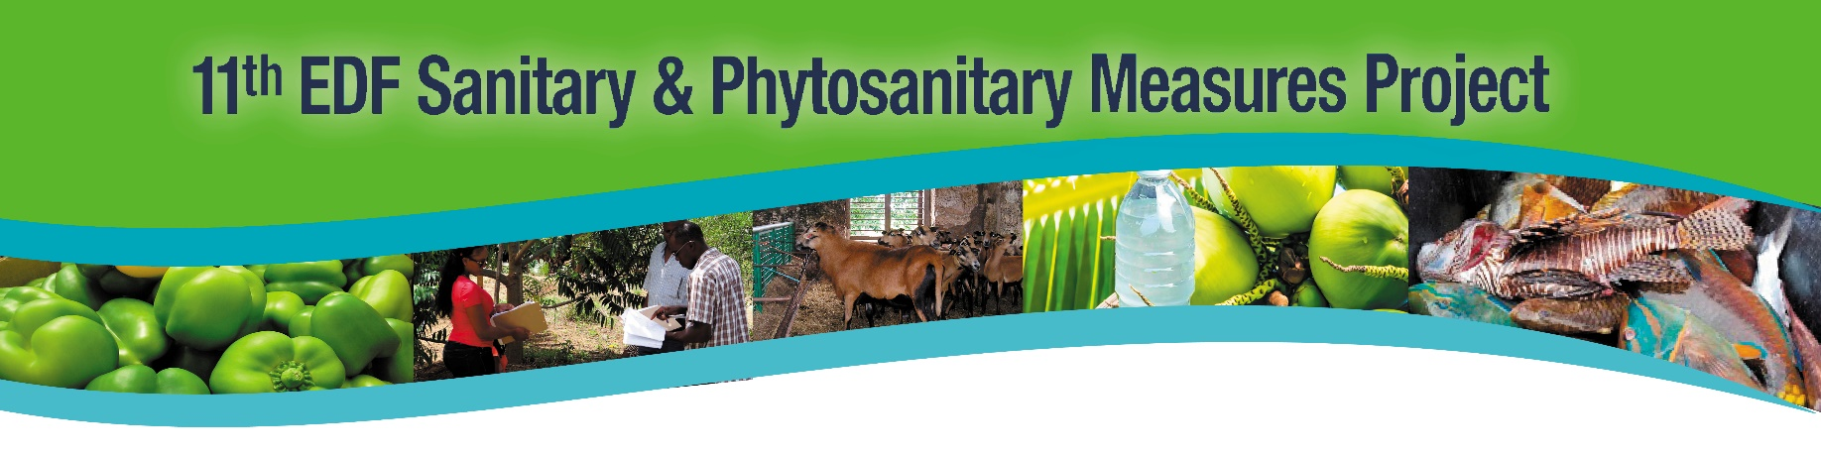
MEDIA RELEASE
Belize Poultry Industry receives Trade and Market Access Boost as
Poultry Health Regulations come into effect

Bridgetown, Barbados, 2nd February 2023 (IICA): The Belize Poultry Health Regulations, Statutory Instrument No. 121 of 2022, published in the Gazette on 25th August 2022, came into effect on 30th November 2022. These regulations will enable the Belize Agricultural Health Authority (BAHA), in collaboration with poultry farmers, to effectively prevent, control, and eradicate poultry diseases. It also calls for effective biosecurity controls at poultry establishments to further safeguard the industry. As part of the implementation process, poultry industry importers, exporters, and other poultry establishments are required to register with BAHA, registration commenced in November 2022.

Xavier Canton-Lamousse, Team Leader/Project Manager of the European Union Technical Support Office to Belize, expressed his satisfaction with the project’s progress to date, “I am delighted that the European Union’s partnership with the Ministry of Agriculture of Belize, BAHA and IICA has contributed to strengthening the Poultry Health regulations here in Belize. The update of the regulations made with the assistance of the European Development Fund Sanitary and Phytosanitary Measures Project, was necessary to ensure that establishments are registered and contain provisions for biosecurity. It will further enhance disease control and traceability of poultry food products in Belize. This is also well aligned with the European Union farm to fork strategy that was designed in 2020 for the EU market. The regulation is now compliant with international standards, and this will give better access to regional and international markets. It will certainly translate into greater export earnings for Belize”.

Since the launch in December 2021 of the strengthening Agricultural Health and Food Safety (AHFS) legislative framework in Belize component of the 11th European Development Fund (EDF) Sanitary and Phytosanitary (SPS) Measures Project, BAHA has been working assiduously to train farmers on the new regulations, specifically registration and biosecurity. As the regulations come into effect the objective was to ensure that poultry producers would be fully sensitised on what they are expected to do. In 2020, the wholesale value of poultry in Belize was more than BZE$104 million. Without the enactment of these essential regulations, the industry would remain vulnerable to disease. These regulations will permit BAHA to take the necessary measures to control and eradicate poultry disease. When these standards are included in national legislation it strengthens the technical capacity of the Veterinary Services, and stakeholders and trading partners can be assured that the local trading measures are in accordance with the appropriate levels of protection required globally.

Speaking at the signing of the Regulations earlier in August, Hon. Jose Abelardo Mai, Minister, Ministry of Agriculture, Food Security and Enterprise in Belize said, “This is a very important milestone in the sanitary and phytosanitary accomplishments of Belize. BAHA is the frontline for the protection of plant and animal health. This is essential to increase future export prospects for Belizean poultry to CARICOM and other markets. We give great importance to achievements like this which in the past have been overlooked. It is

time that we step up the game to keep at the level of other countries. The important thing about this regulation is that it provides for traceability and registration of commercial producers and other establishments. We must monitor and report these diseases. Surveillance of poultry disease and biosecurity is critical to ensure that producers keep disease from spreading and entering farms. This is a winning moment for our poultry industry, for our poultry producers, for our economy, because this is what will keep our poultry industry alive.”

This enabling structure will allow Belize to safeguard food security, animal health, public health, and the environment; and applies to both commercial and backyard poultry operations. The successful completion of this component of the project ensures that Belize now has regulations that facilitate the enforcement of SPS measures for improved production, market access and trade of poultry. Compliance with these regulations will increase market opportunities not only with the European Union but also the Caribbean Region and will further contribute to integrating Belize into the world economy by boosting the competitiveness of Belizean products.

Zoe Zetina, Managing Director of BAHA, thanked stakeholders for their input, “The 11th EDF Sanitary and Phytosanitary Measures Project main objective was to increase compliance with international SPS measures, standards, and procedures to improve international and regional market access. Specifically, within Belize its role was also to enhance BAHA’s legal framework and to repeal SI-47 of 1982. In Belize both the public and private sector will benefit from the decision that Belize made to focus on the Poultry Health Regulations that was signed in August. I thank the European Union for providing the funds necessary for this project, the Inter-American Institute for Cooperation on Agriculture (IICA) Project Implementation Team; the IICA Belize Delegation; the project consultants; the Belize Poultry Association; the Ministry of Agriculture, Food Security and Enterprise; the Attorney General’s Ministry of Belize; Ministry of Foreign Affairs, Foreign Trade and Immigration; Ministry of Health and Wellness; and the BAHA team of the Animal Health and Food Safety departments and other poultry sector stakeholders for their support in getting this legislation passed.”

Stakeholders can obtain more information from BAHA by contacting the Animal Health Department at (+501) 824 4899.

- ENDS -

Caption for attached photograph:
Hon. Jose Abelardo Mai, Minister, Ministry of Agriculture, Food Security and Enterprise signing the Belize Poultry Health Regulations Statutory Instrument No. 121 of 2022, late last year.

Press Release Online: https://www.edfspscariforum.online/media/media-releases

About 11th EDF SPS Measures Project
IICA is the executing agency for the 11th European Development Fund (EDF) Sanitary and Phytosanitary (SPS) Measures Project, which aims to increase compliance by CARIFORUM States with international SPS measures, standards, and procedures to increase international and regional market access. Project activities will contribute towards accessing the benefits of the Economic Partnership Agreement (EPA) – a trade and development agreement between CARIFORUM States and the European Union, for which the overall objective is to contribute to the integration of these States into the world economy. Additionally, targeted interventions will strengthen regional harmonised SPS measures which are critical to advancing the CARICOM Single Market and Economy (CSME).
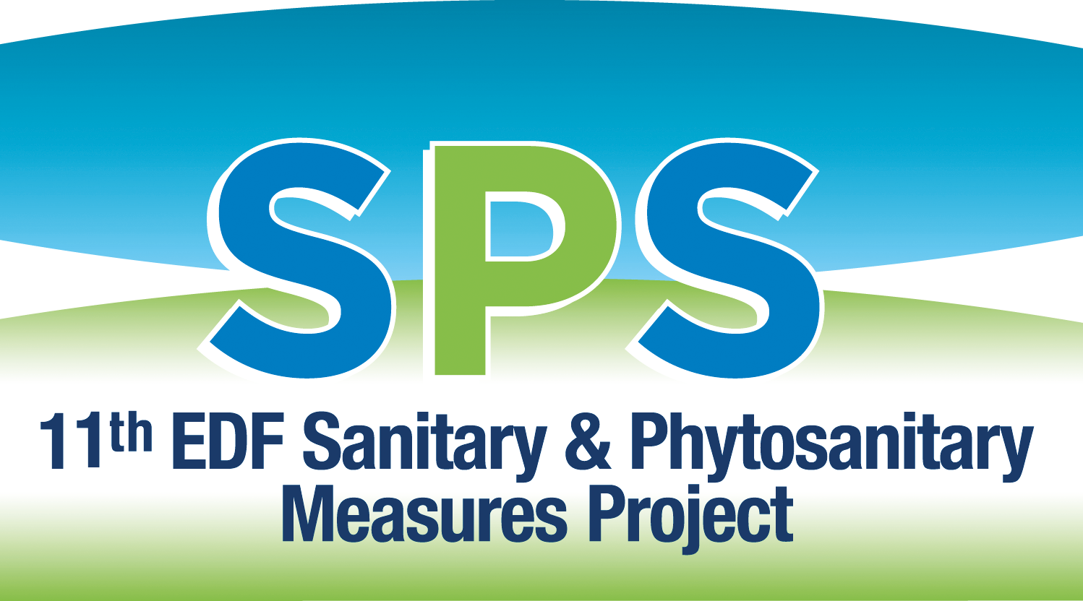
For more information:
11th EDF SPS Measures Project
Project Communications: (+1 868) 773 4069 – Mobile/WhatsApp, info@edfspscariforum.online
11th EDF SPS Measures Project, IICA Barbados Delegation, Suite B1 B2, Building #1, Manor Lodge Complex, Lodge Hill, St. Michael, BB12001 BARBADOS
Phone: 1 (246) 271-9210 / 9211 / 9212
Website: https://www.edfspscariforum.online/
LinkedIn: https://www.linkedin.com/company/iica-barbados-11th-edf-sps-measures-project/
Facebook: https://www.facebook.com/11th-EDF-SPS-Measures-Project-102806985274944

